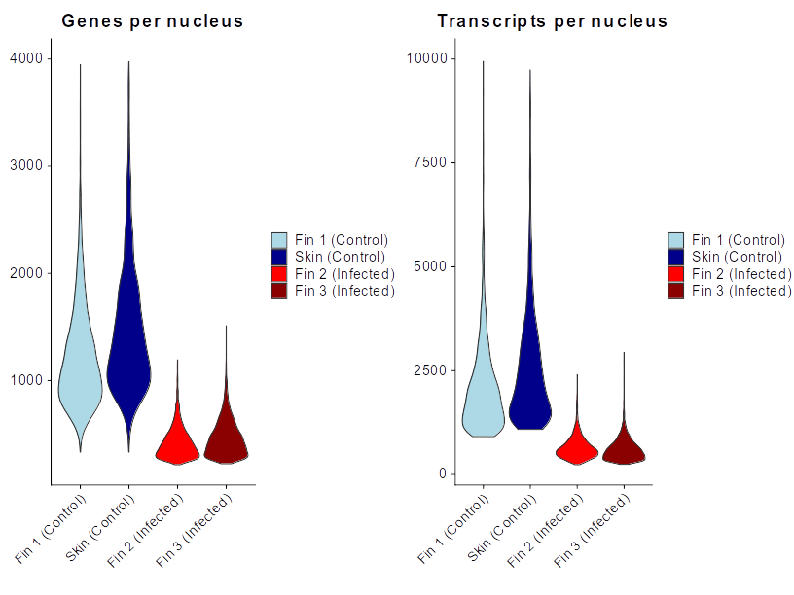

Figure 1: A comparison of metrics of single nuclei libraries using TST based protocols on challenging tissue types. In red, those done using the protocol as described in Taylor et al. 2022. In Blue, libraries done with the modifications described in this protocol.

